Experiment No 7
LAB MANUAL
PART B

Roll No. C-60 | Name: Avdhut Parish Madhavi
Class: SE-C | Batch: C2
Date of Experiment: | Date of Submission:
Grade:
B.1: Implement and trace the following programs. Write the code, compile/run it, and record the output after each task.
- Run the program with a different set or order of items and verify the maximum value obtained using the Dynamic Programming table.
CODE:
#include <stdio.h>
#include <conio.h>
int max(int a, int b)
{
if(a > b)
return a;
return b;
}
void main()
{
int wt[4] = {2, 3, 4, 5};
int val[4] = {3, 4, 5, 6};
int K[5][8];
int i, w;
clrscr();
for(i = 0; i <= 4; i++)
{
for(w = 0; w <= 7; w++)
{
if(i == 0 || w == 0)
K[i][w] = 0;
else if(wt[i-1] <= w)
K[i][w] = max(
val[i-1] + K[i-1][w-wt[i-1]],
K[i-1][w]);
else
K[i][w] = K[i-1][w];
}
}
printf("Weight Value\n");
for(i = 0; i < 4; i++)
printf("%d %d\n", wt[i], val[i]);
printf("\nCapacity = 7\n");
printf("Maximum value = %d", K[4][7]);
getch();
}

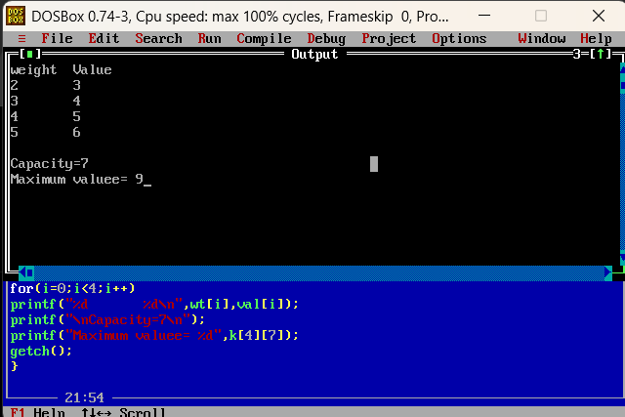
- Do the analysis of the 0/1 knapsack problem using Dynamic Programming.
CODE:
#include <stdio.h>
#include <conio.h>
void main()
{
int n, W, i, j, cells;
clrscr();
printf("Enter number of items: ");
scanf("%d", &n);
printf("Enter knapsack capacity: ");
scanf("%d", &W);
cells = (n + 1) * (W + 1);
printf("\nDP table size = %d x %d", n+1, W+1);
printf("\nTotal table cells = %d", cells);
printf("\nTime Complexity = O(nW)");
printf("\nSpace Complexity = O(nW)");
printf("\n\nAnalysis:");
printf("\nEach table cell is calculated once.");
printf("\nHence time complexity is O(nW).");
printf("\nThe table requires O(nW) space.");
getch();
}

